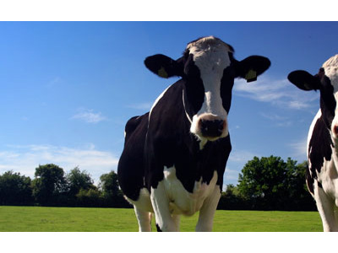
CHG Dairy wipes
NEW in
2014

Response Product Data Sheet
Product Code: 42800
Product Type: Pre-Moistened Dairy Wipe; CHG Bucket
Product Description: Response brand Dairy Towels product. CHG Teat Wipe Bucket (2 buckets/case); 1100 Count
Thickness: 1-ply
Packaging: Case - 32/Pallet
Width (std): 8in | Width (met): 20.32cm
Length (std): 10in | Length (met): 25.4cm
Weight (std): 22lbs | Weight (met): 10kg
Related Products: 41800 · 21168 · 44800 ·
Features/Benefits
Sanitizing Teats in pre and post milking process without dips or foams. Prepping and cleaning injection sites and other treatable areas of livestock. Active Ingredient: Chlorhexidine Gluconate (CHG).

